Lecture 7 Static Timing Analysis
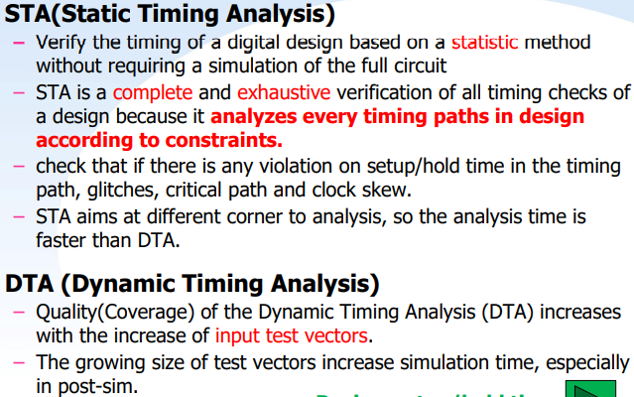
Clock source latency: Clock source latency is the delay from the clock source to the clock definition point (CLK); Source latency could represent either on-chip or off-chip latency.
Clock network latency: from the clock definition point (CLK) to the clock pin of a flip-flop.
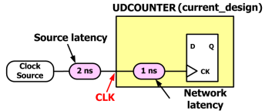
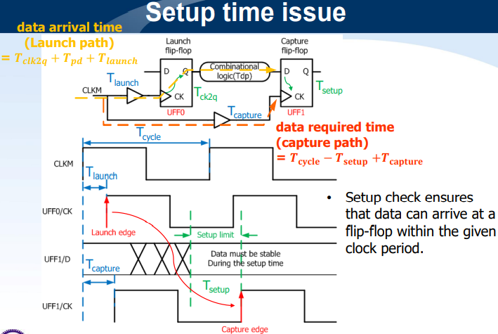
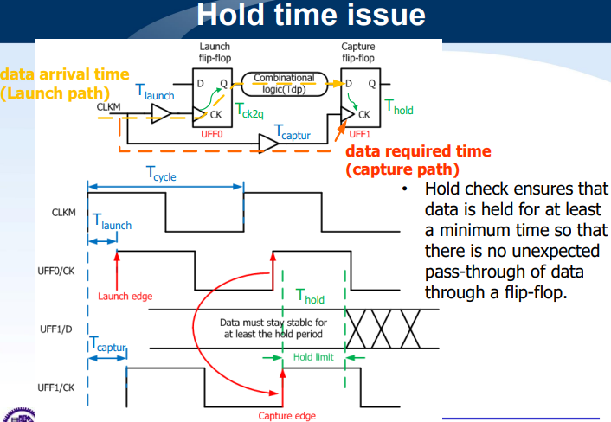
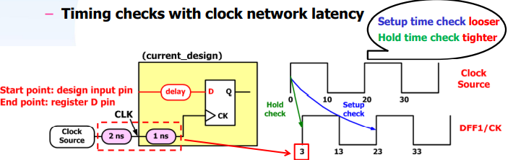
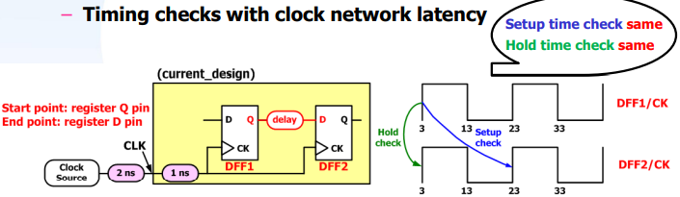
Clock network delay = source latency + network latency
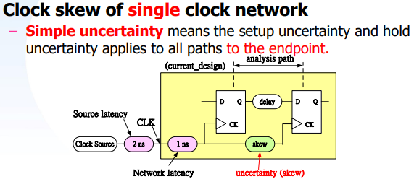
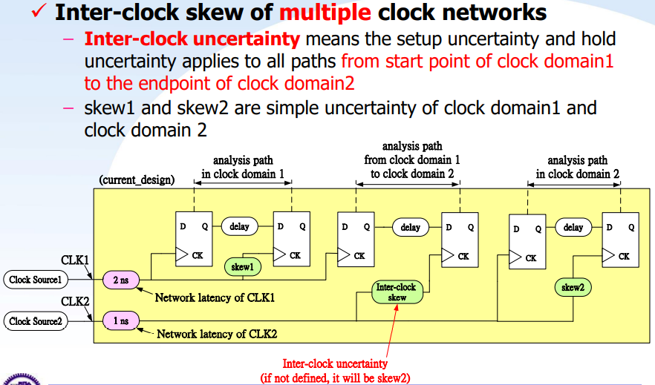
Plus uncertainty is for hold time check.
Minus uncertainty is for setup time check.
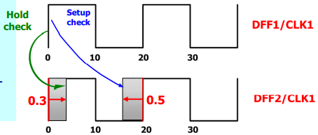
If inter-clock uncertainty is not defined, compiler will use uncertainty of CLK2 automatically.
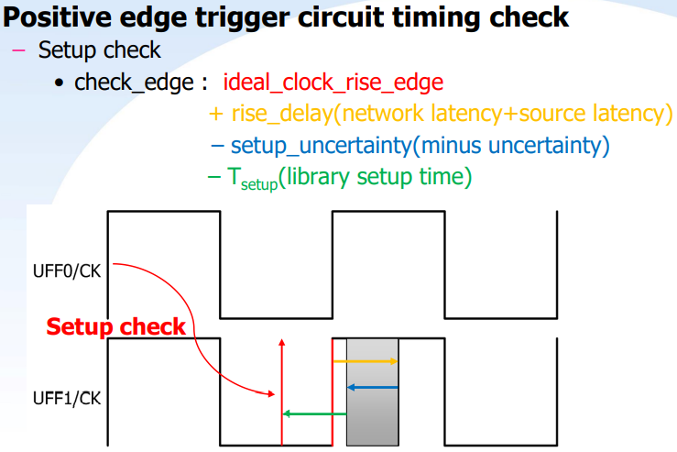
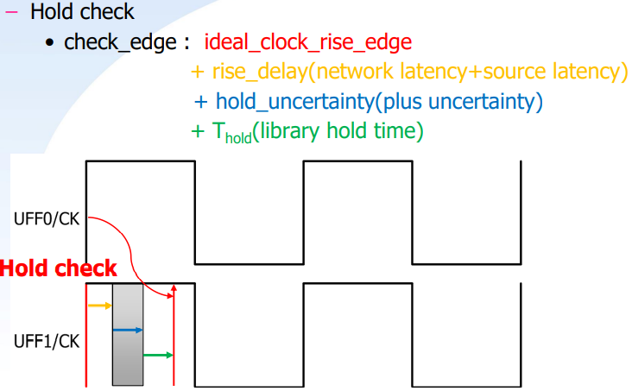
Why multicycle path ?: A timing path which is not expected to propagate a signal in one cycle, set multicycle paths to direct compiler to allow multiple clock cycles for data to propagate along a path.
- Specify multiple path for setup time check – Hold time check edge will be changed too!!
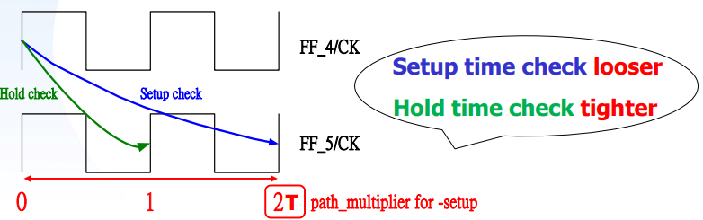
- Specify multiple path for hold time check.
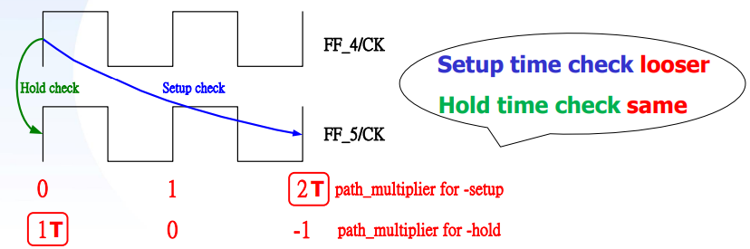

Example:
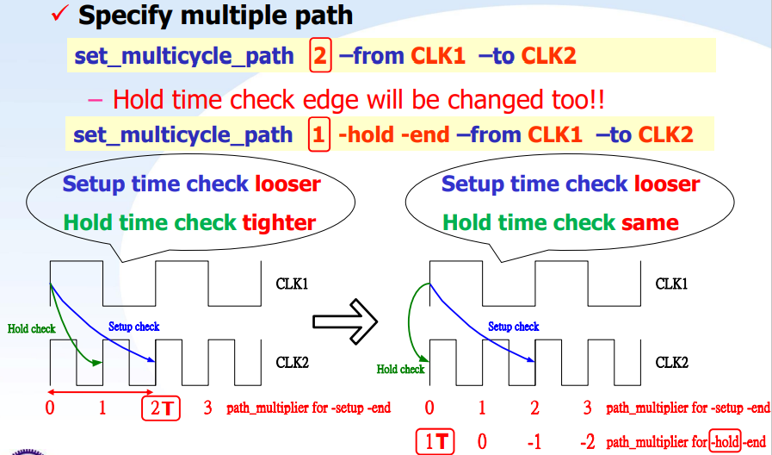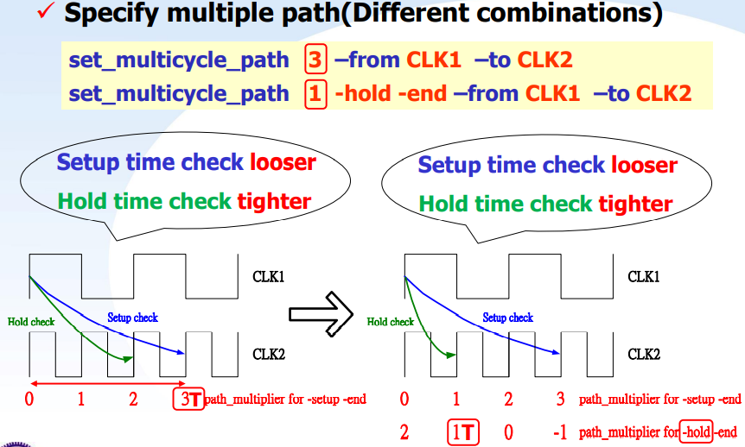
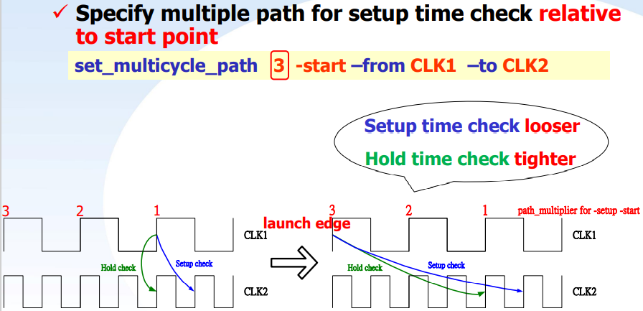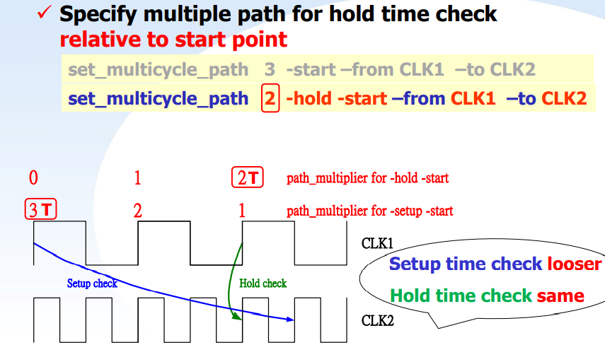
- Why we need to use clock domain crossing (CDC): Because different blocks require different clock period, some blocks need long clock period to operate, but others only do simple work. If we all use long clock period, it will cause the performance to be poor.
- The unstable status due to non-ideal data transition is called metastability.
- CDC solution:
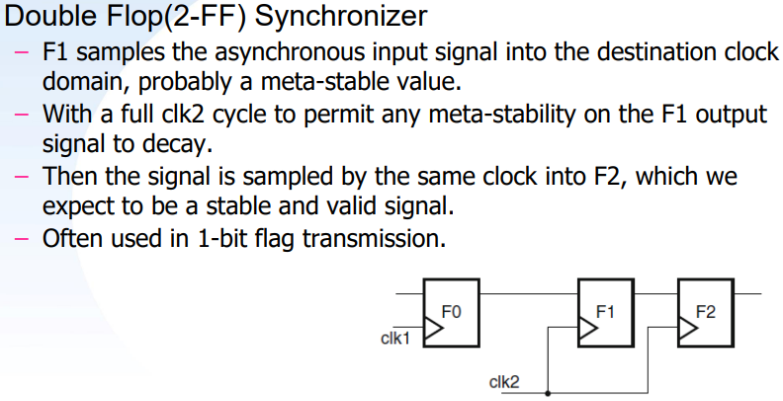
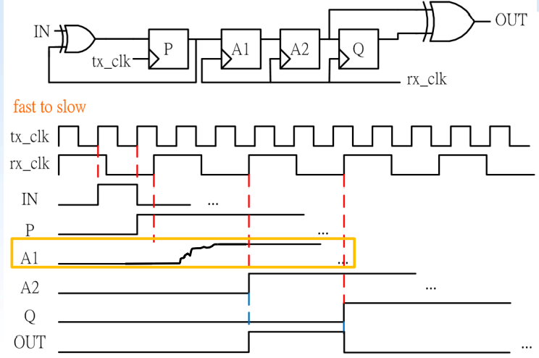
Specify False Path: Remove timing constraints from particular path – Timing checks of false path will be disabled.
set_annotated_check: Using PrimeTime tool rewrite the sdf file to ignore some timing checks.
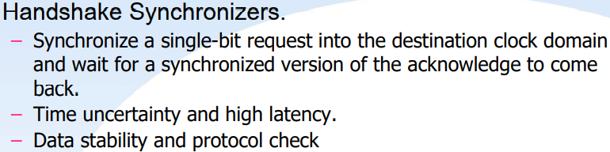

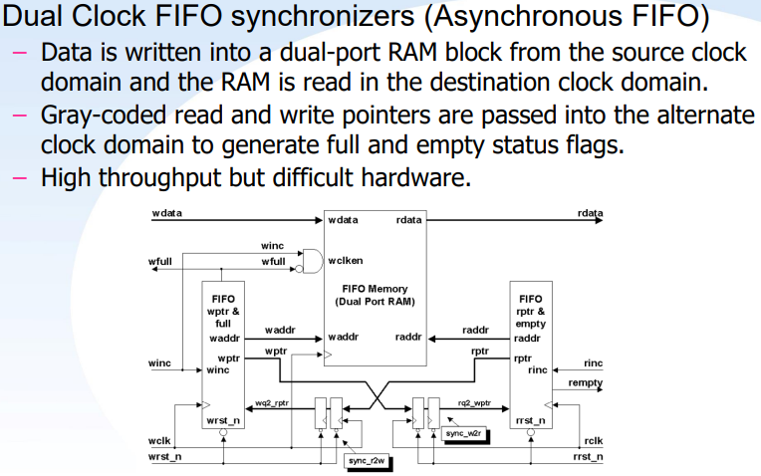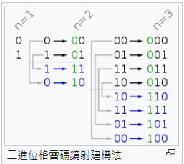
Setup time determines max value of tpd.
Hold time determines min value of tpd.
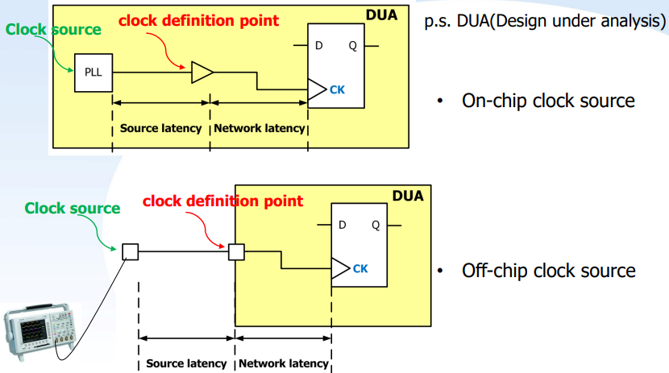

Lecture 8 SystemVerilog
Why SystemVerilog?
- Designs efficiency– Need to code for reuse and higher abstraction – Need more efficient coding constructs with native language support
- System level hardware design/verification languages
- Testbenches are growing exponentially – Find a way to generate more useful test data and make testing faster
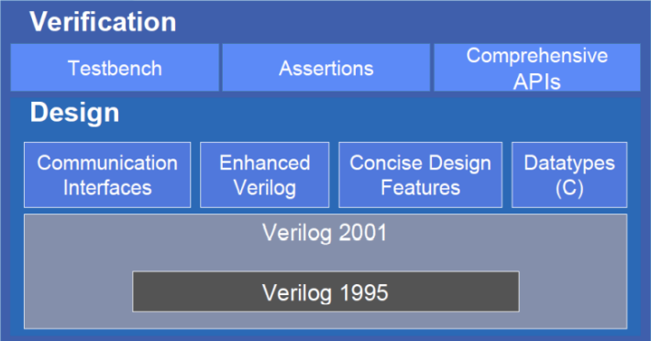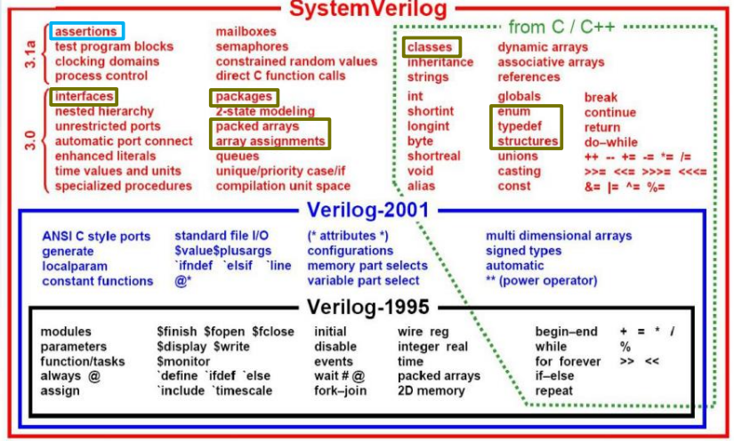
testbed.sv – Connecting testbench and design modules, Generating clock, Dump waveform
design.sv – Design under test (DUT)
pattern.sv – Pattern, Test program, Assertion, Coverage
Program:
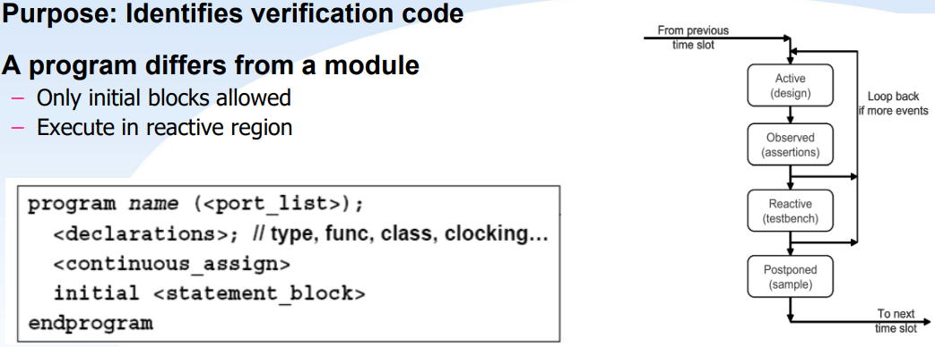
Verilog:
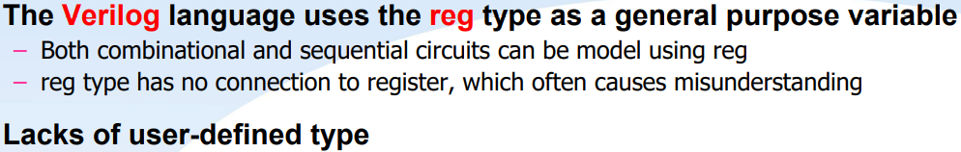
SystemVerilog:
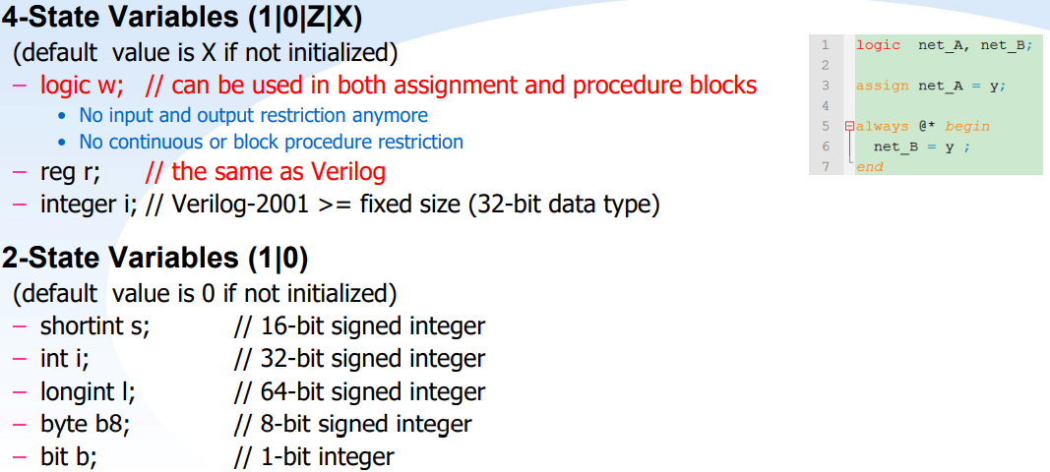
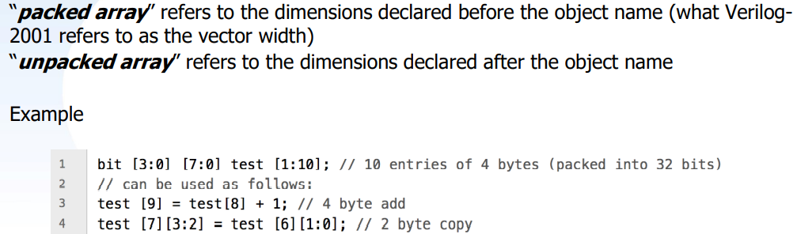

Typedef:
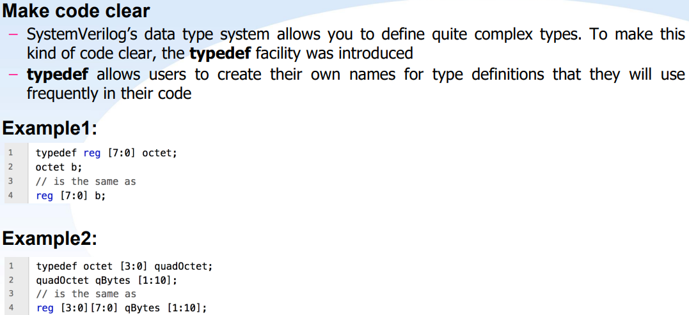
Enumerate(Enum):
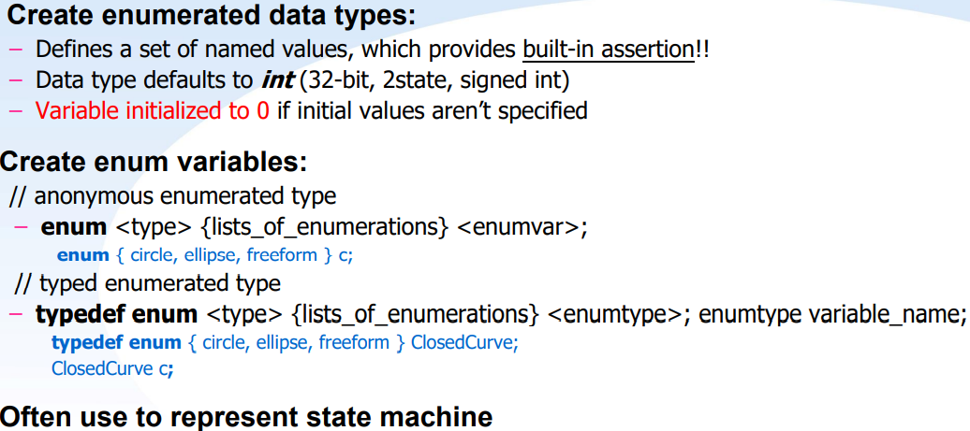
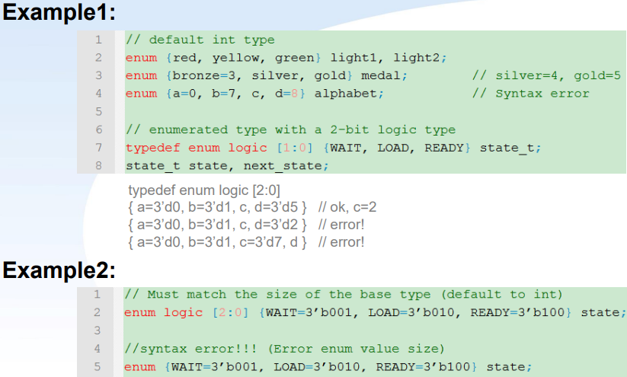
Structure(Struct):
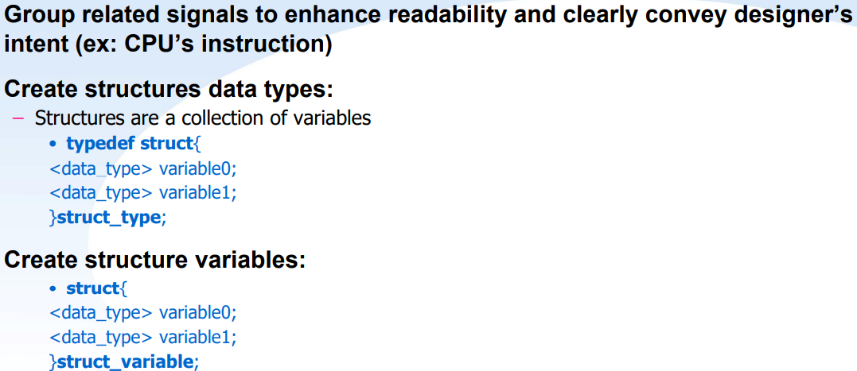
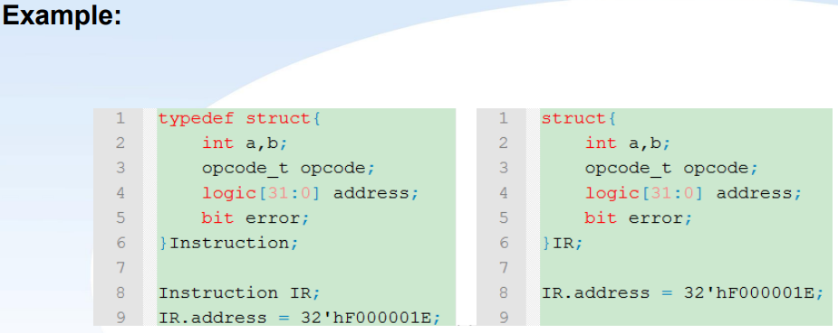
Union:
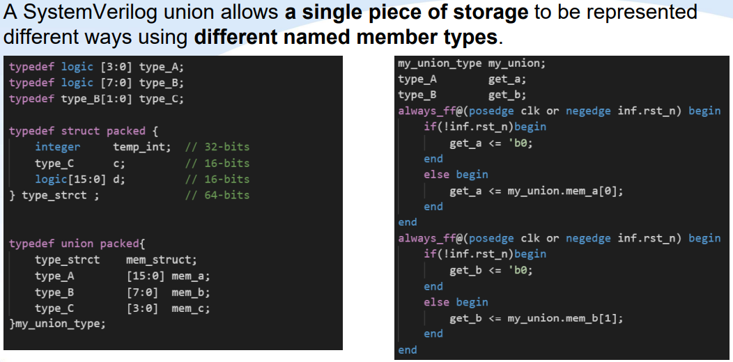
Struct vs. Union: https://gaexp251546.pixnet.net/blog/post/67520022

Package: To enable sharing a user-defined type definition across multiple modules, SystemVerilog adds packages to the Verilog language.
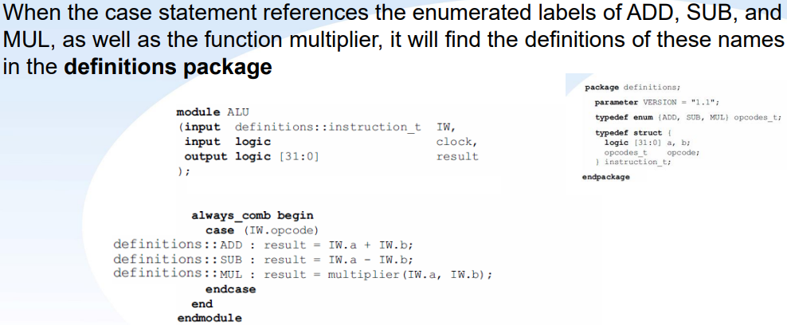
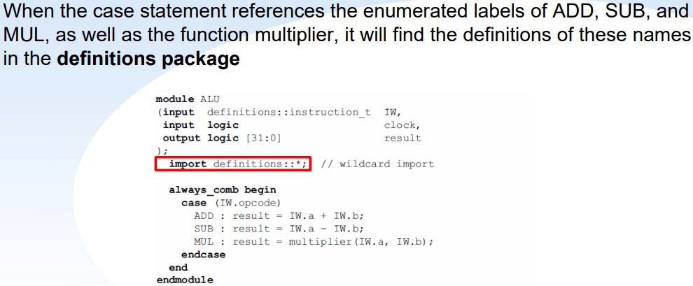
In Verilog, there are 2 kinds of procedure block – initial, always.
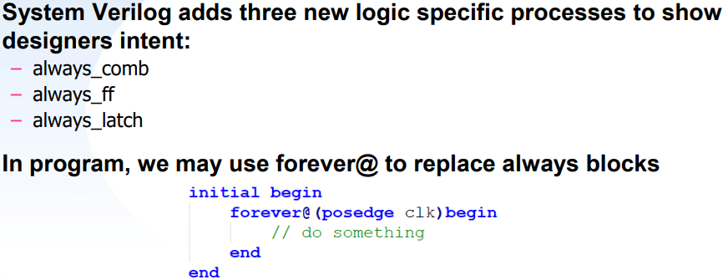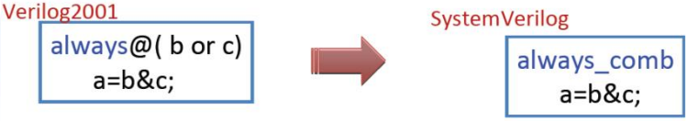
The always_ff procedural block is used to indicate that the intent to model synthesizable sequential logic behavior.
The always_latch procedural block is used to indicate that the intent to model combinational logic with latch in it.

An interface is a named bundle of wires, similar to a struct, except that an interface is allowed as a module port, while a struct is not.
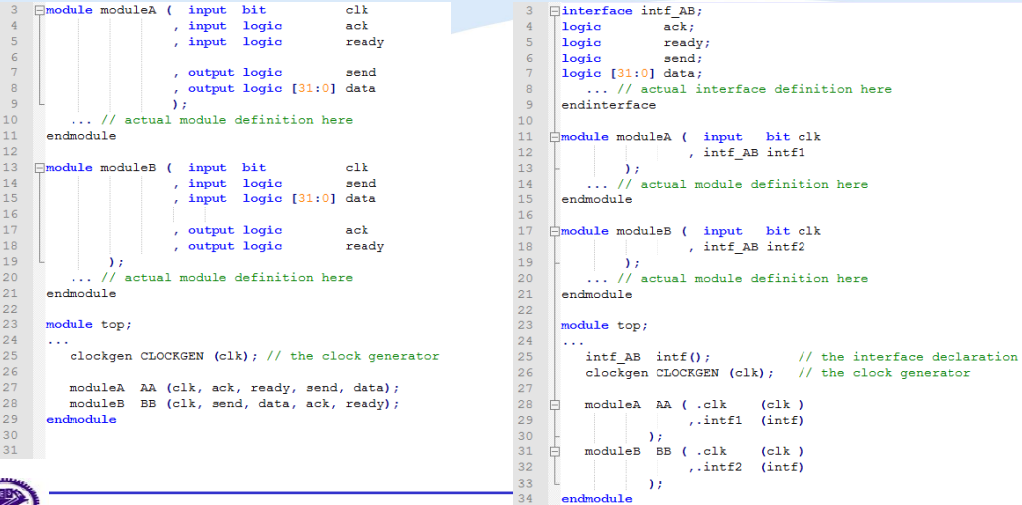
Modports are used to define direction of signal inside interface.
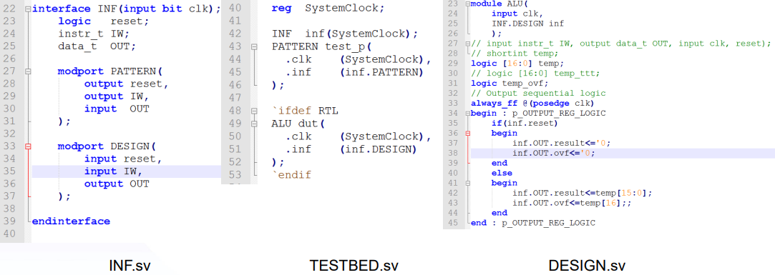
Object-oriented programming:
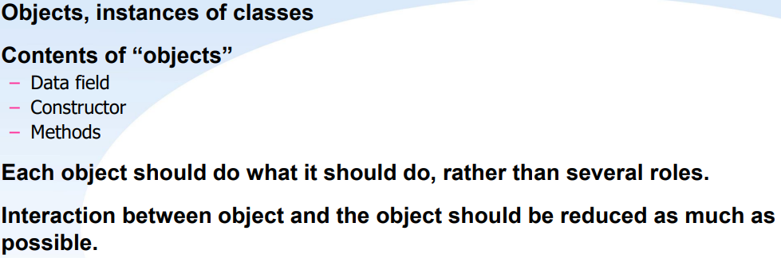
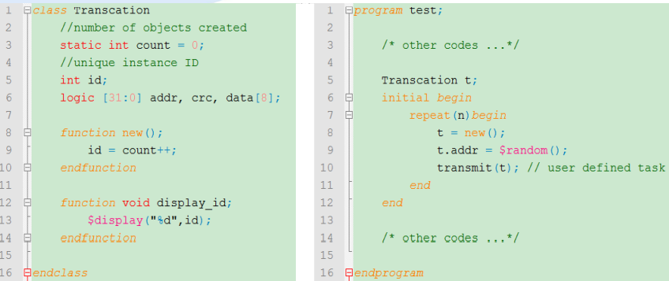
Randomization:
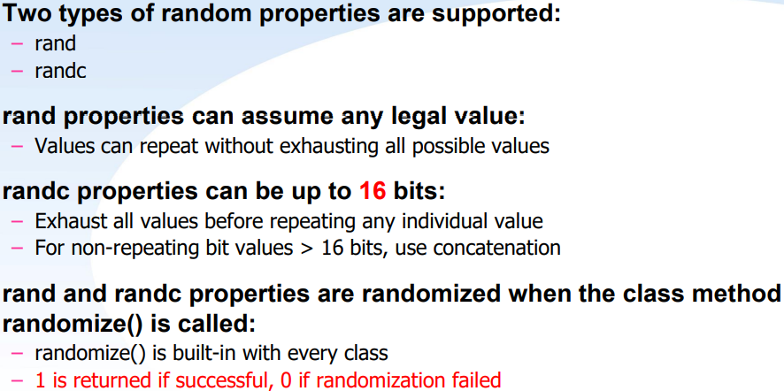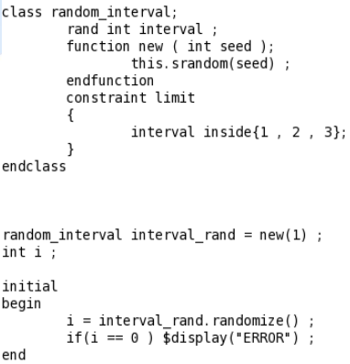
Constraints:
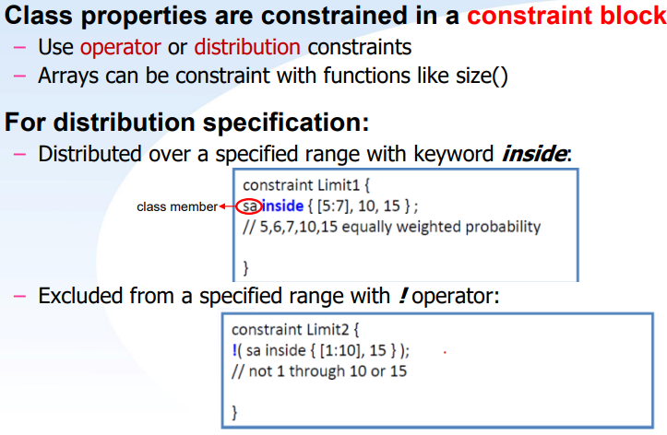

Lecture 9 SystemVerilog Verification
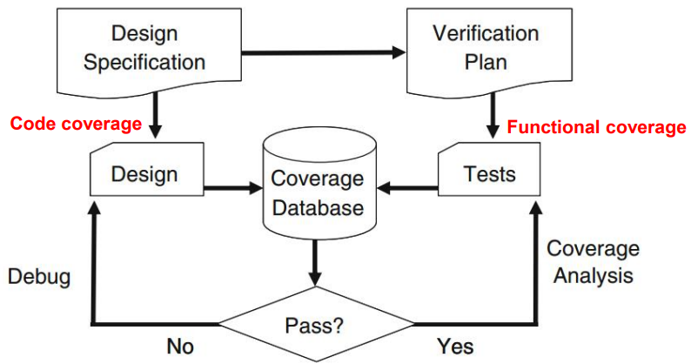
Multiple cover points sample at the same time are placed together in a cover group.
A cover group can sample any visible variable directly such as program variables, signals from an interface, or any signal in the design.
Create a cover group which encapsulates:
– Group of cover points
– Bins definitions
– Coverage goal
– Defining Coverage bins sample timing
– Track progress
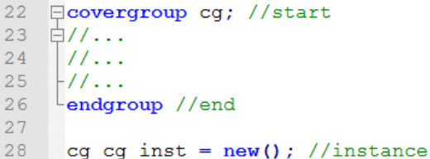
Bins are updated synchronously as the sample_event occurs – Can also use cov_object.sample() to update the bins.
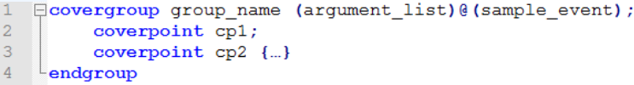
IFF:
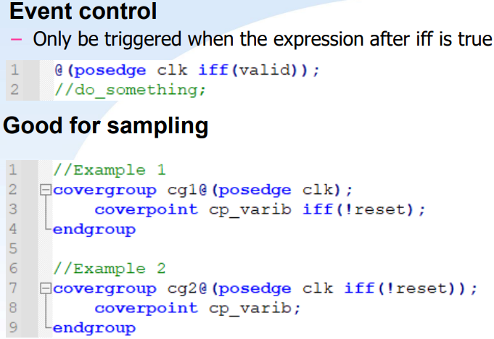
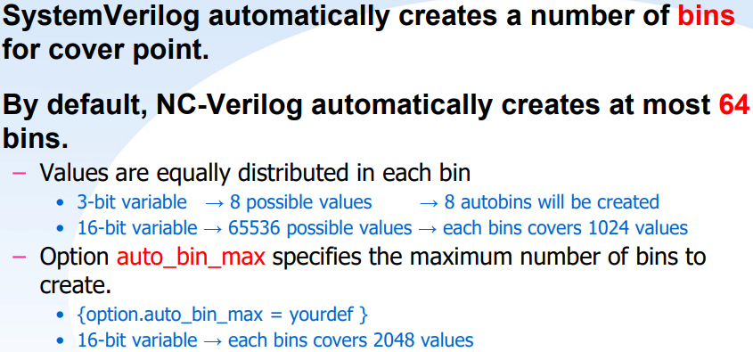
What is bin? bin is a container for each value in the given range of possible values of a coverage point variable.
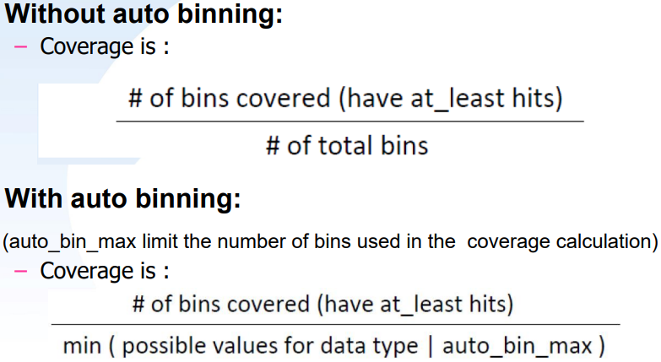
Each covergroup contributes equally.
Within covergroup, each coverpoint/cross block contributes equally.
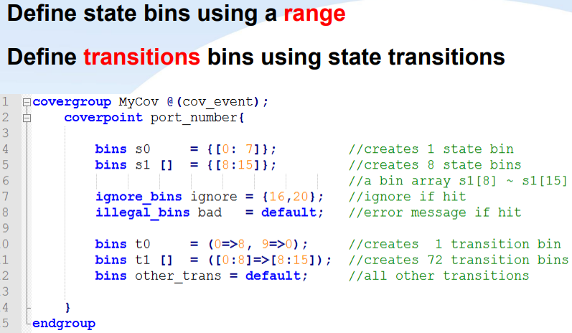
SystemVerilog can automatically create cross coverage bins.
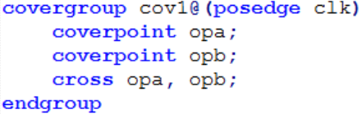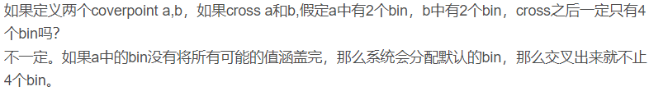
Cross bins for all combinations of the individual state.
at_least(1): – Minimum number of times for a bin to be hit to be considered covered. auto_bin_max(64): – Maximum number of bins that can be created automatically.
– Each bin contains equal number of values.
per_instance(0): – Keeps track of coverage for each instance when it is set true.

Options control the behavior of the cover group, coverpoint, and cross.
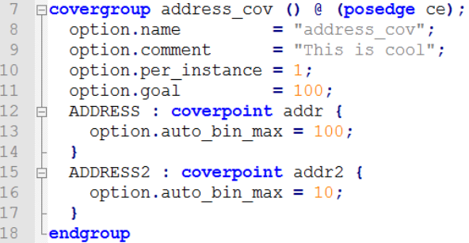
Assertion: An assertion is a design condition that you want to make sure never violates.
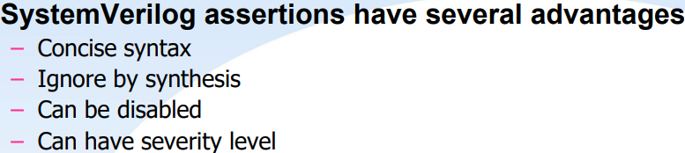
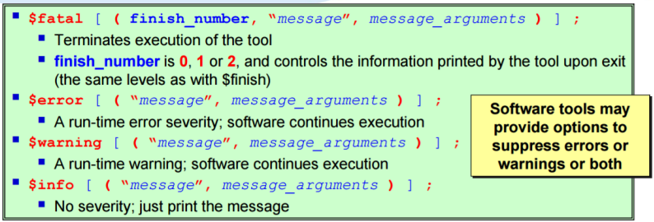
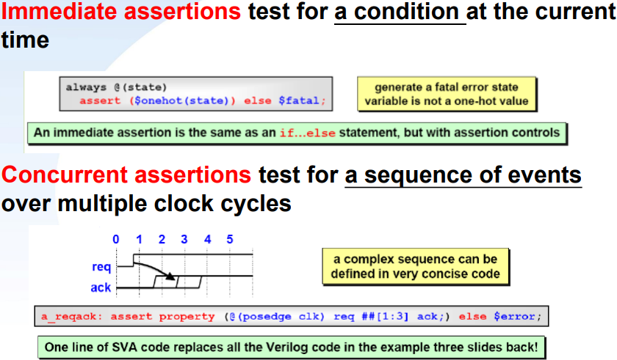
Immediate Assertions:
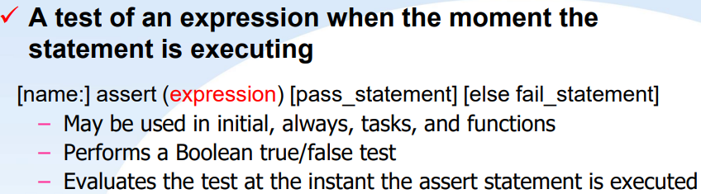
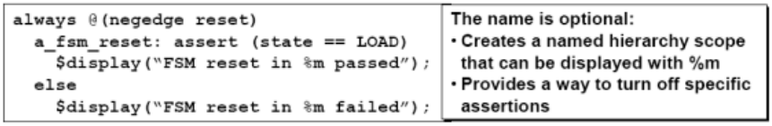
Concurrent Assertions:
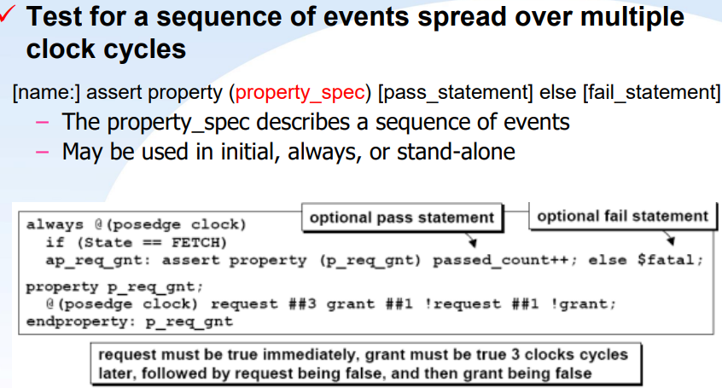
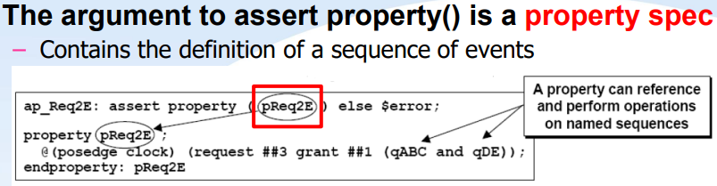
## represents a “cycle delay” – Specifies the number of clock cycles to wait until the next expression in the sequence is evaluated.
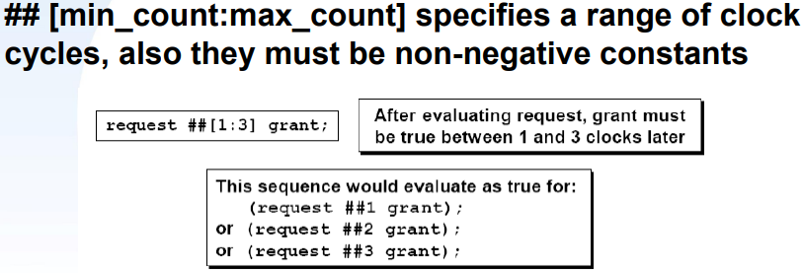
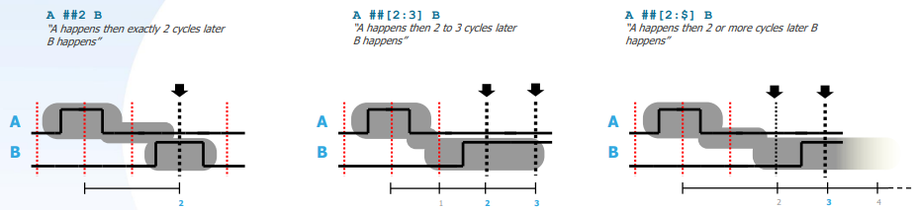
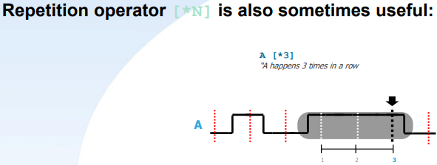
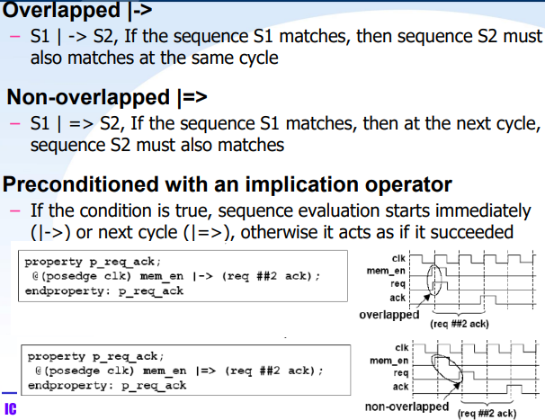
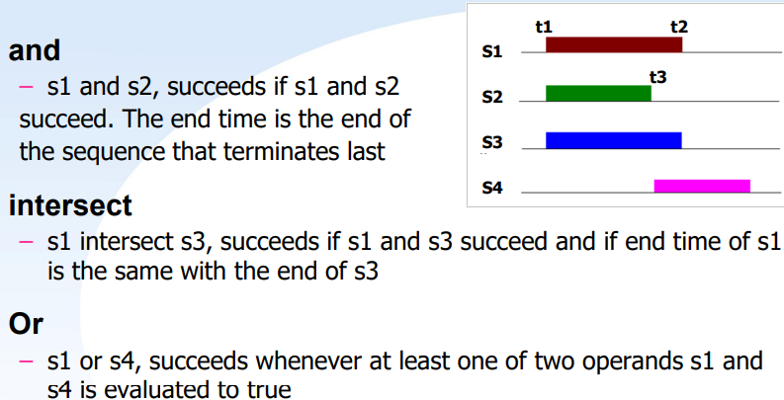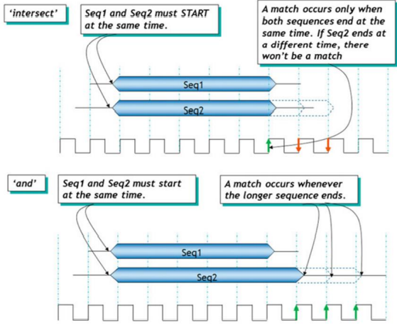
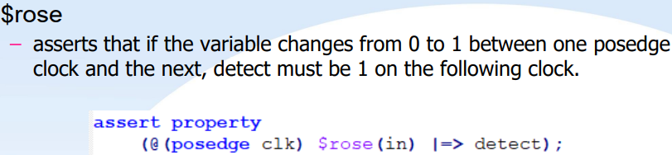
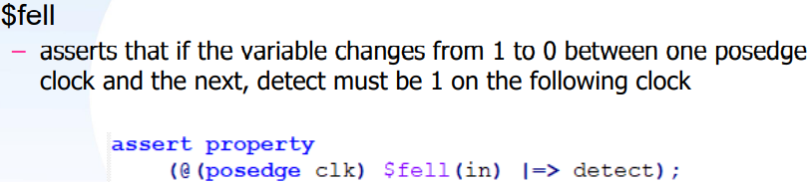
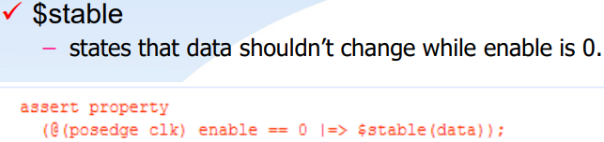
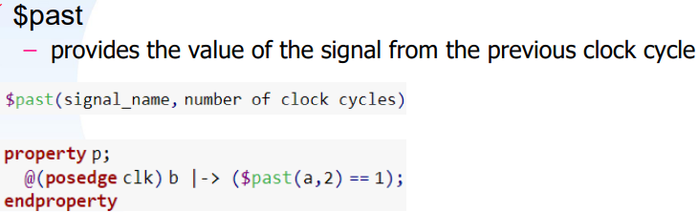
Lecture 10 Low Power Design
Why low power? -- Power↑ ➔ Temperature↑ ➔ Safety↓
Power Dissipation:
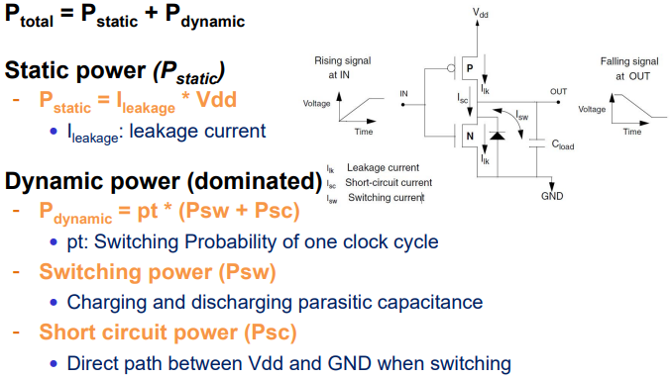
Static Power Dissipation:
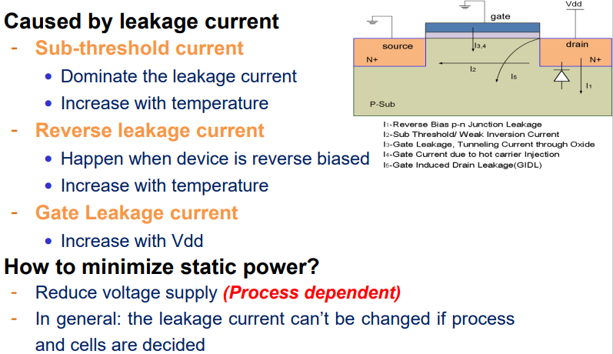
Dynamic Power Dissipation:
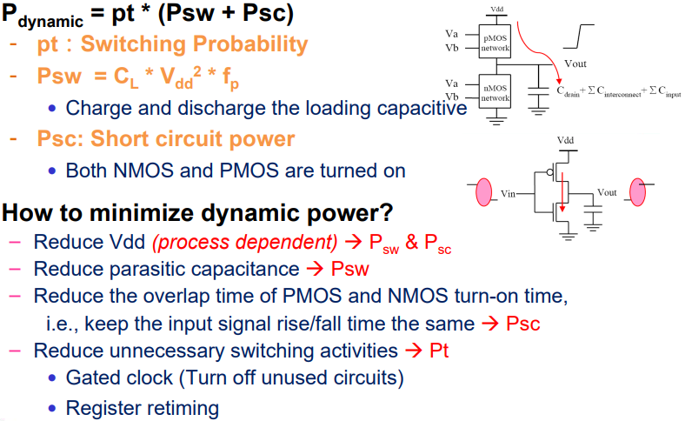
Where to reduce power?
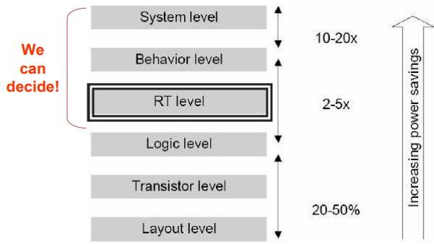
Static Power Reduction -- Multi Threshold Voltage
As Vt decrease, sub-threshold leakage increases -- Vt ↓, IDS_sub ↑, ID(SAT)↑
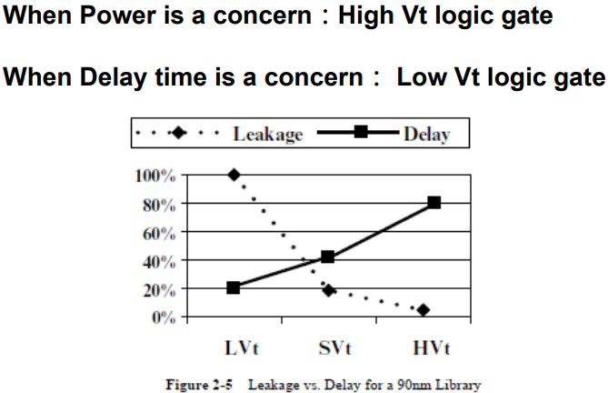
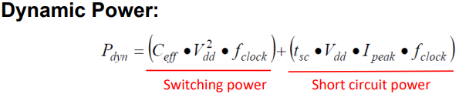
Reducing the Vdd is the most straight forward way to reduce the power. However, decreasing Vdd would cause the circuit delay increasing.

Multi Voltage Strategies:
➢ Static Voltage Scaling (SVS): ‐ Different blocks or subsystems are given different, fixed supply voltages.
➢ Multi-level Voltage Scaling (MVS): ‐ A block or subsystem is switched between two or more voltage levels. ‐ Only a few, fixed, discrete levels are supported for different operating modes.
➢ Dynamic Voltage and Frequency Scaling (DVFS): ‐ An extension of MVS where a larger number of voltage levels are dynamically switched to follow changing workloads.
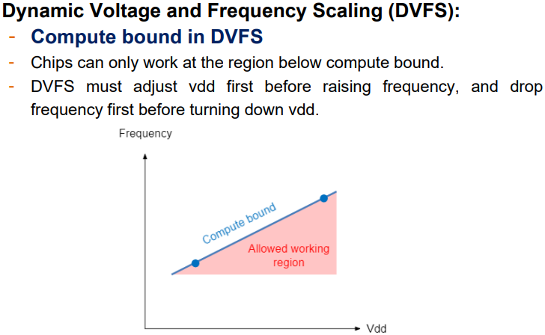
Level Shifter:
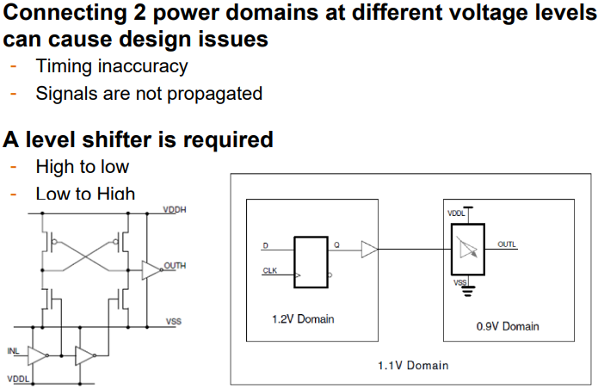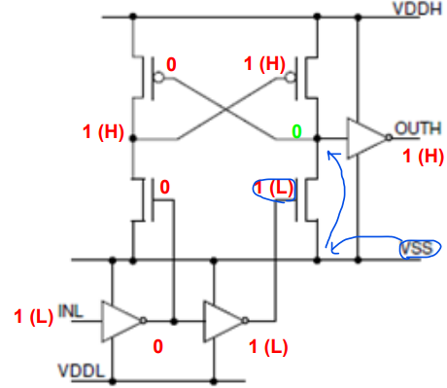

Power Gating:
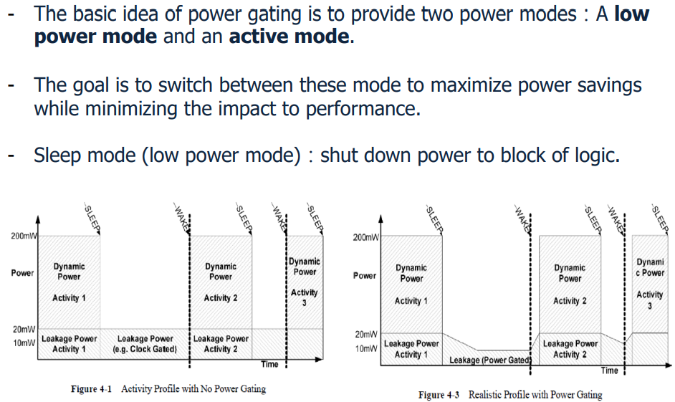

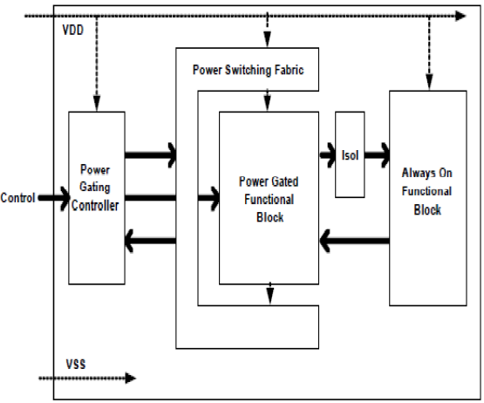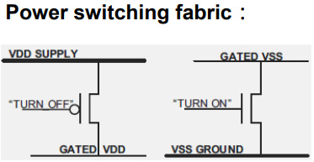
Example: (Isolation)
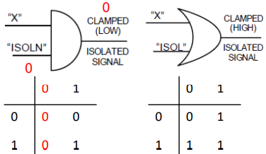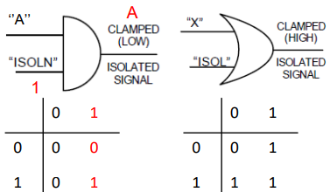
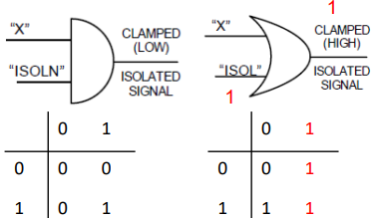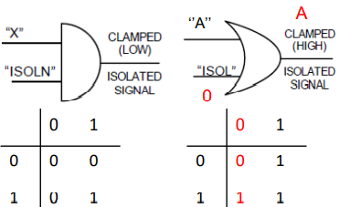

Retention(保留) registers:
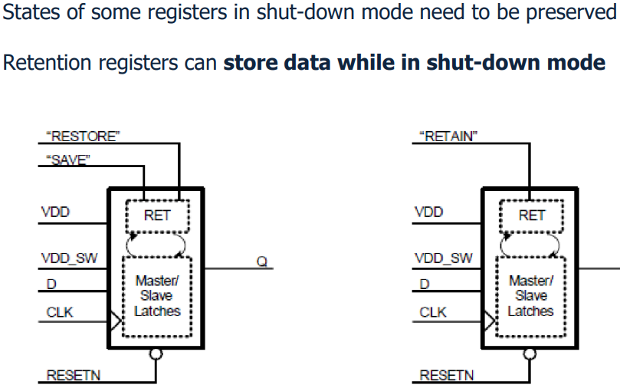
Power gating needs a control circuit to schedule the whole procedure.
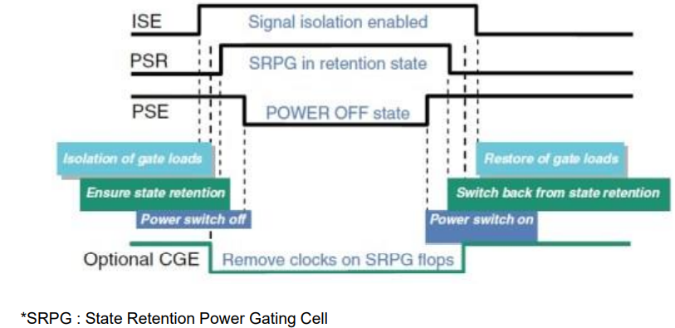
Unified Power Format (UPF):
➢ Unified Power Format: TCL-based power specification file.
➢ UPF files consists of commands and objects that describe power intent.
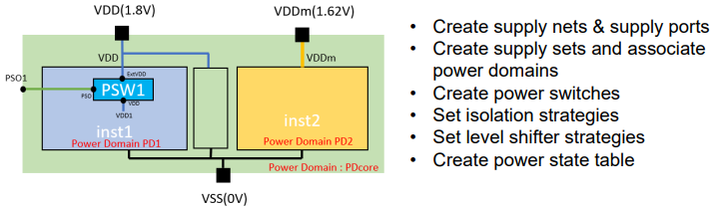
Architecture Trade-offs: Power/Frequency/Area
- Pipeline
- Parallel

Dynamic Power Gating:
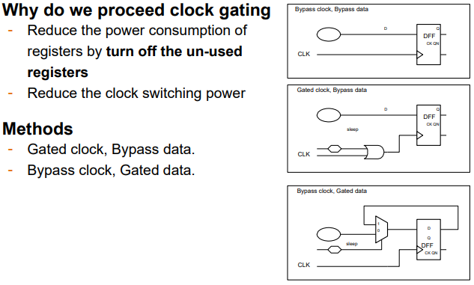
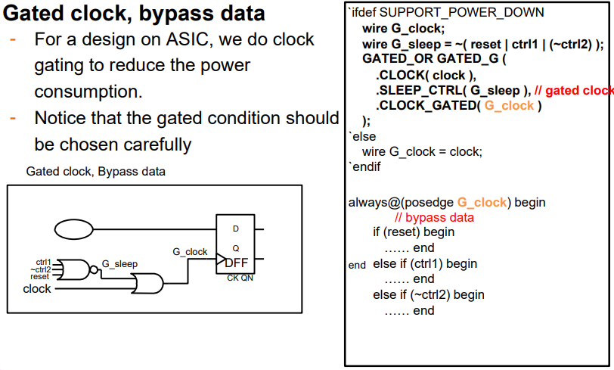
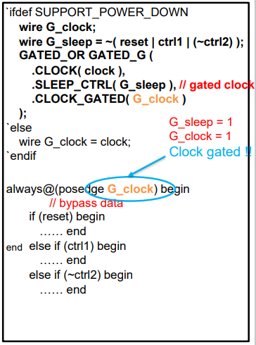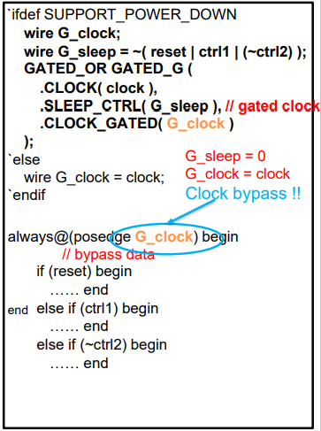
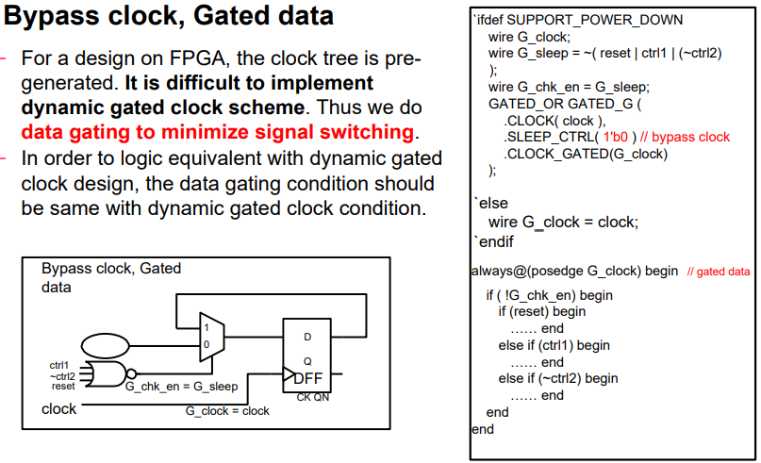
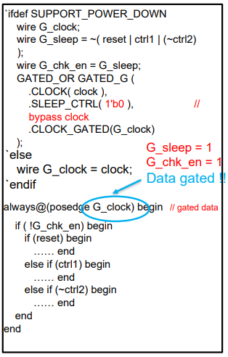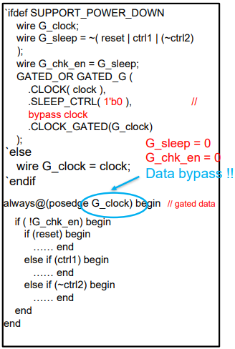
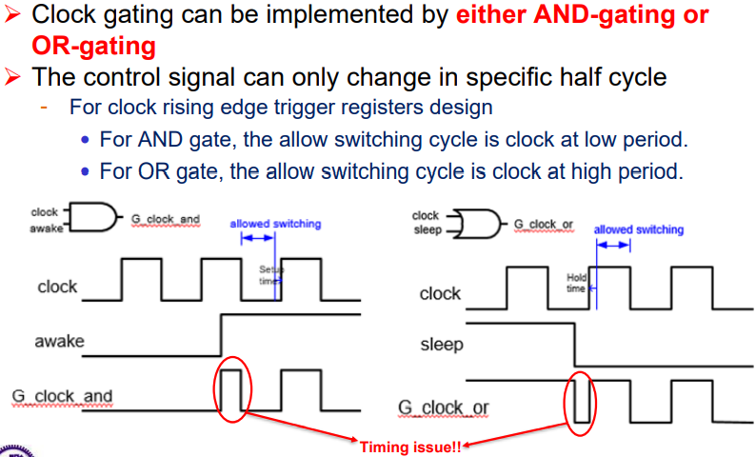
Glitch:
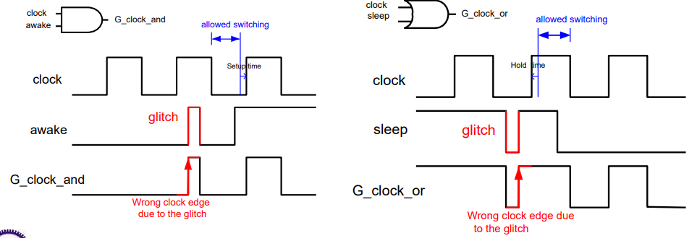
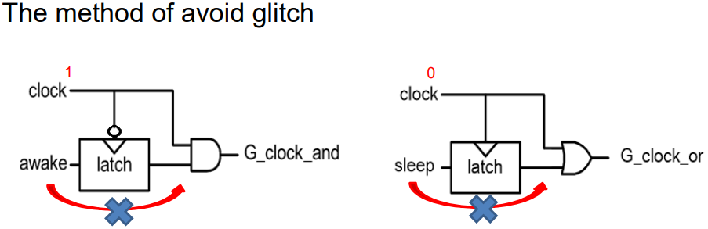
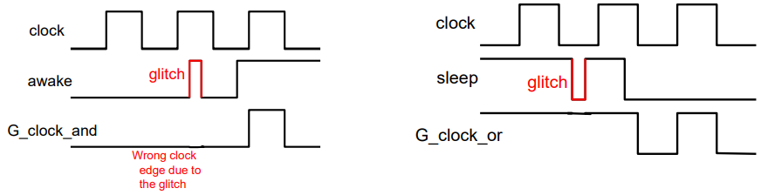
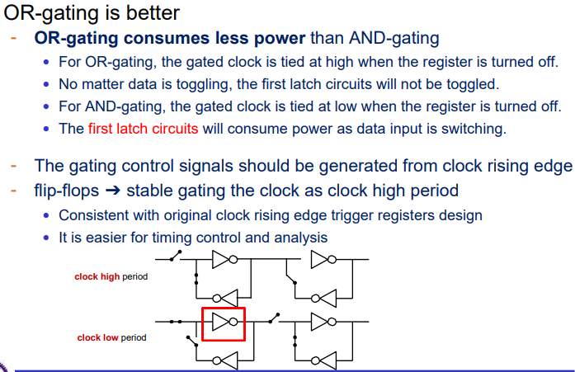
Writing OR gate in a single module can prevent the OR gate from being optimized with other logics during the synthesis.
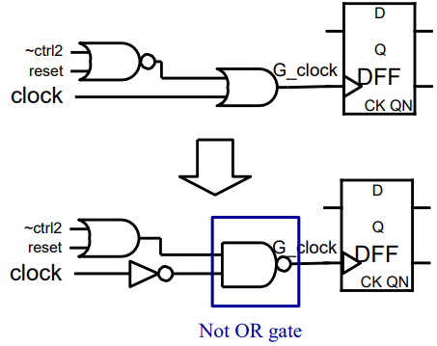
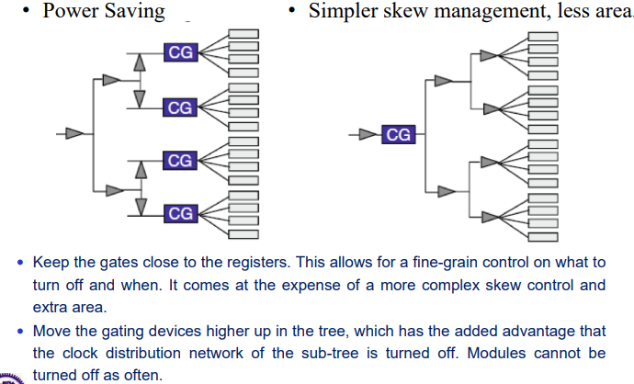
Lecture 11 Cell-Based APR Design Flow

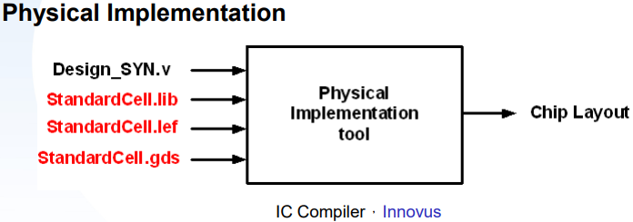
APR design flow:
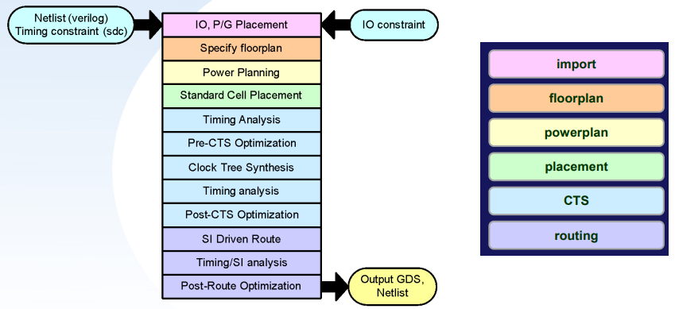
Libraries:
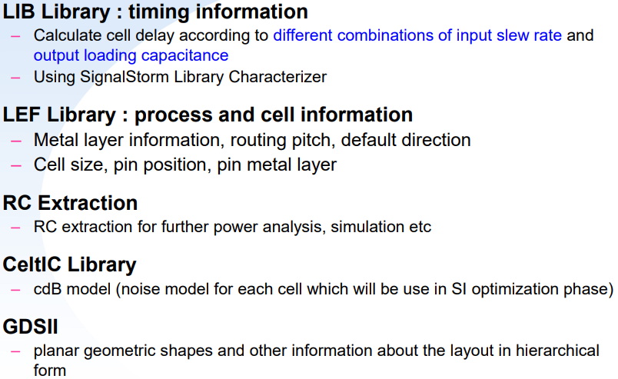
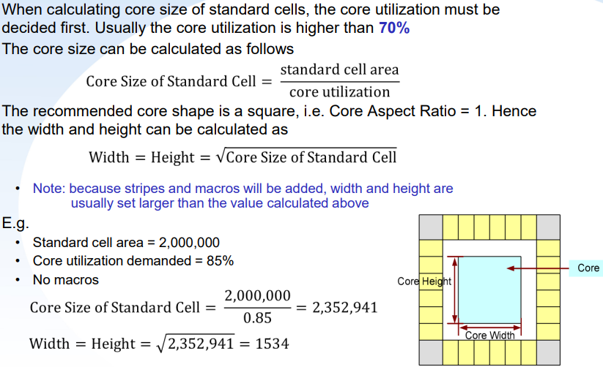
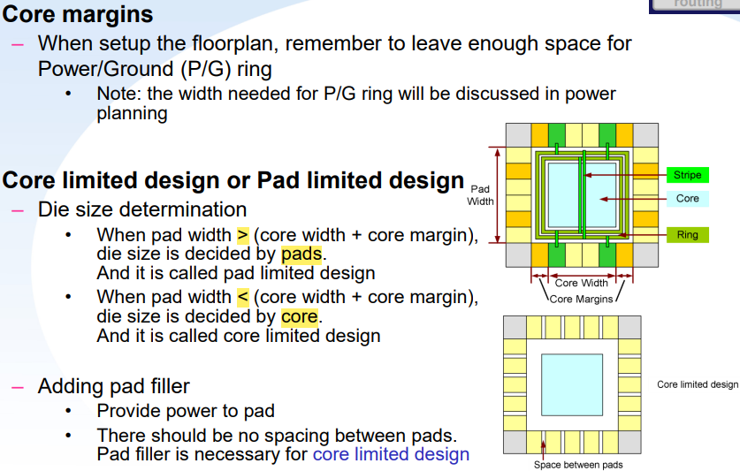
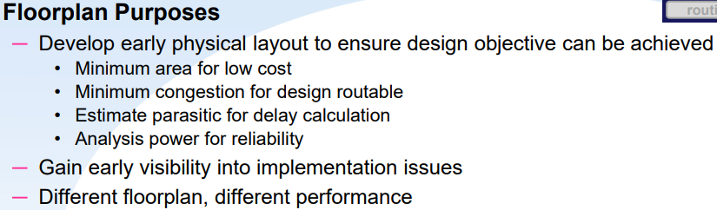
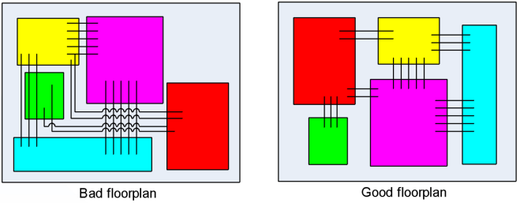
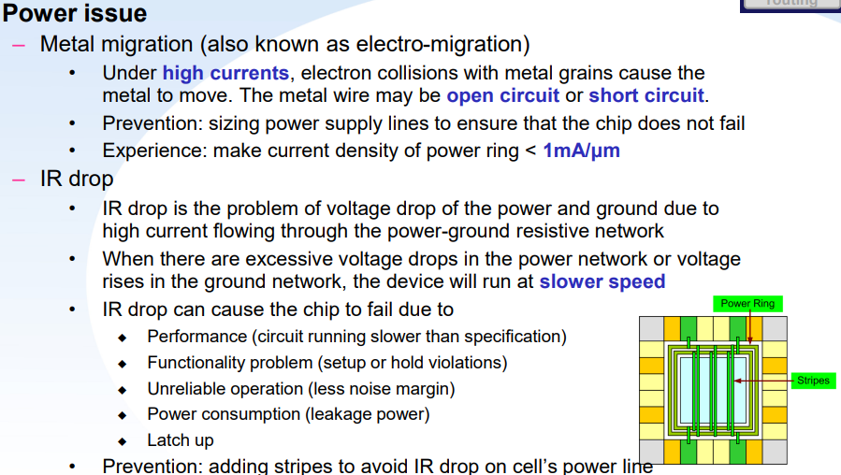
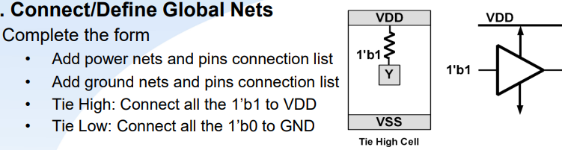
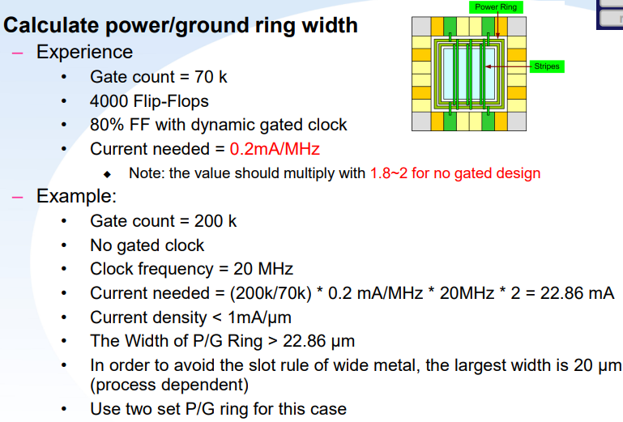
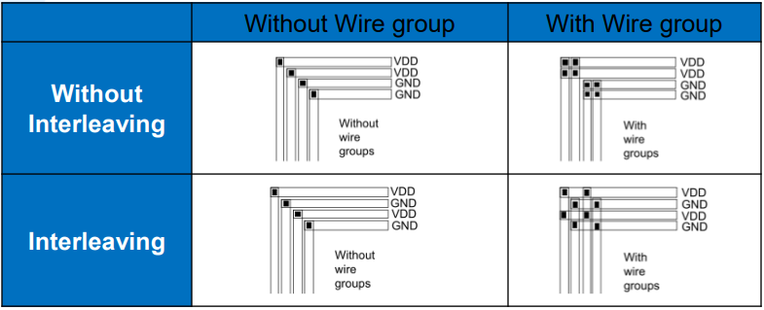
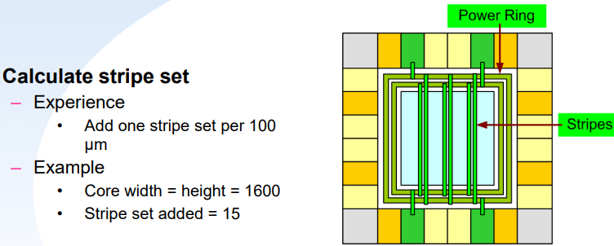
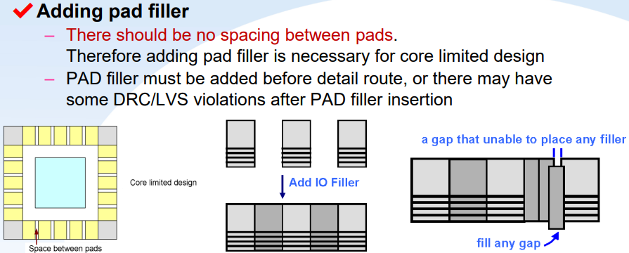
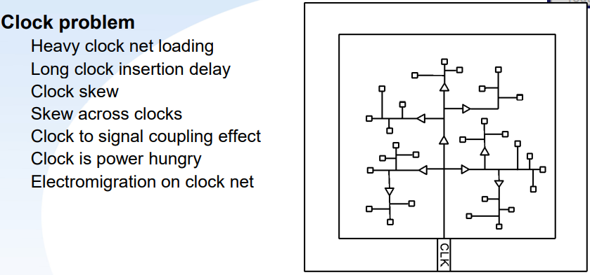
Clock is one of the most important treasure in a chip, do not take it as other use.
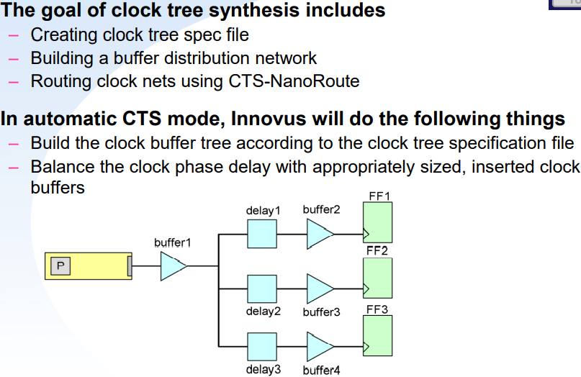
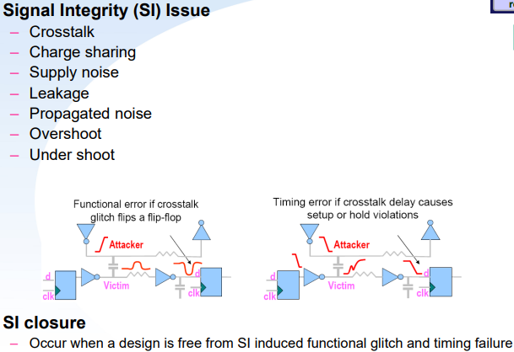
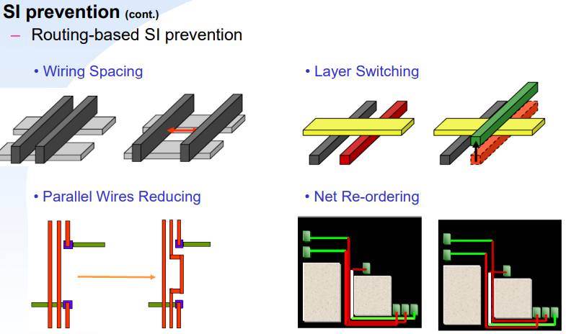\

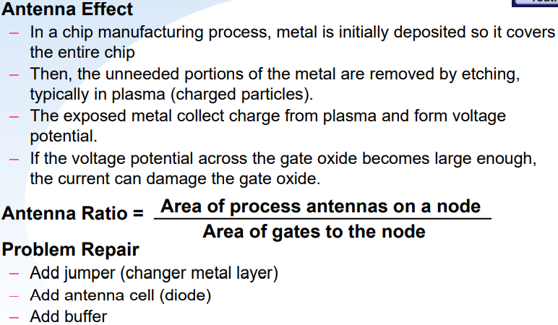
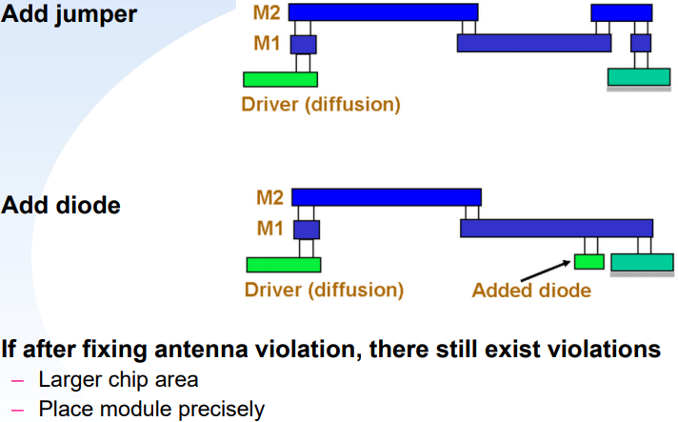
NanoRoute
– Routing the design without creating DRC or LVS violations.
– Routing the design without degrading timing or creating signal integrity violation.
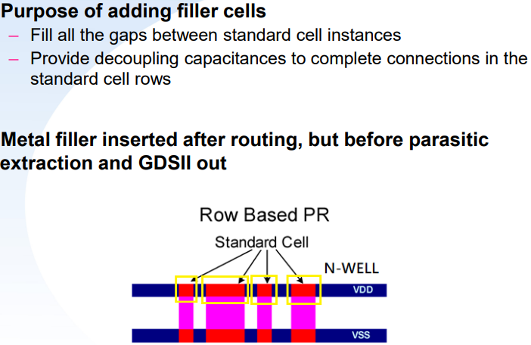
LVS v.s. DRC v.s. DRV
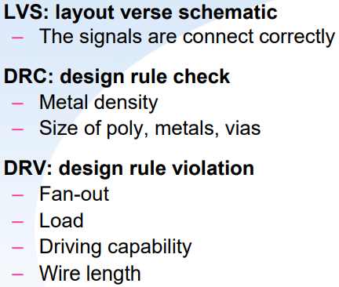
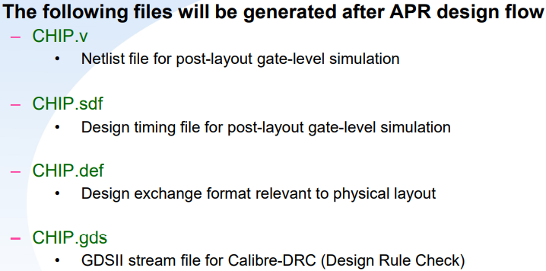
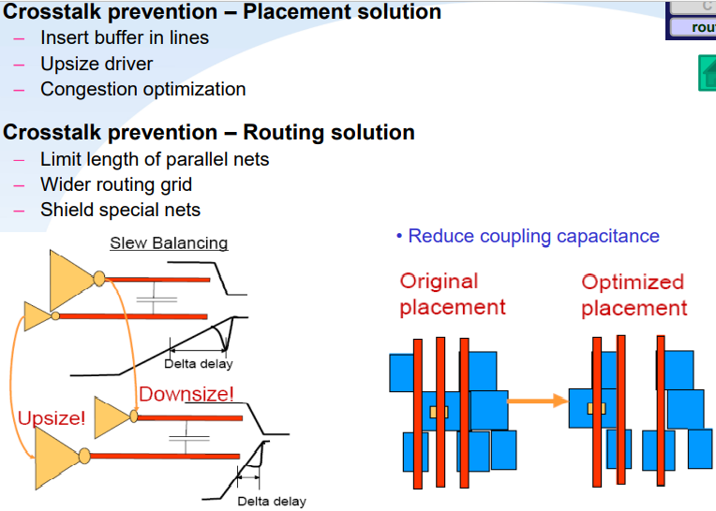

Lecture 12 Things to do after layout
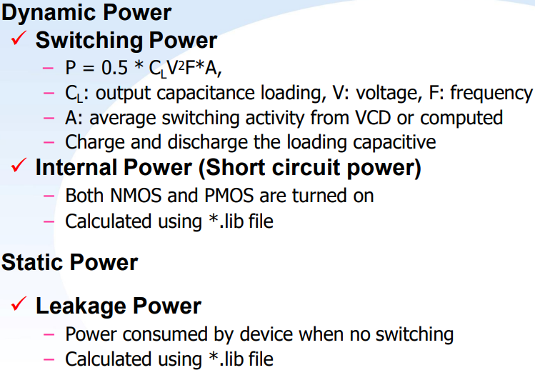

IR drop (IRD)
• IR drop is the problem of voltage drop of the power and ground due to high current flowing through the power-ground resistive network.
• The drop in supply voltage over the length of the supply line.
• When there are excessive voltage drops in the power network or voltage rises in the ground network, the device will run at slower speed
• As the process becoming more and more advanced, the IR drop turns to be an important issue.
• IR drop can cause the chip to fail due to
◆Performance (circuit running slower than specification)
◆Functionality problem (setup or hold violations)
◆Unreliable operation (less noise margin)
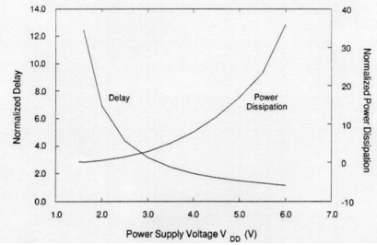
• Prevention:
• 1. Adding stripes to avoid IR drop on cell’s power line
• 2. Change the position of power pad to avoid long power line
• 3. Use square-shaped Chip to avoid long power line
• 4. Add decoupling cell

Electro -Migration (EM)
– EM is the unwanted transport of material due to movement of ions in a conductor, caused by a transfer of momentum from electrons to these ions.
– High-density current in a narrow metal wire may destroy the wire.
– Performance Degradation
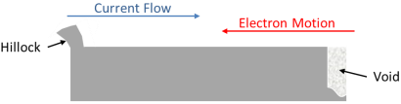
• Increase/decrease in wire RC
– Can result in catastrophic failure
• Open
• Short
– EM analysis solution
• Calculates the current on each wire and compares it to foundry EM rules.

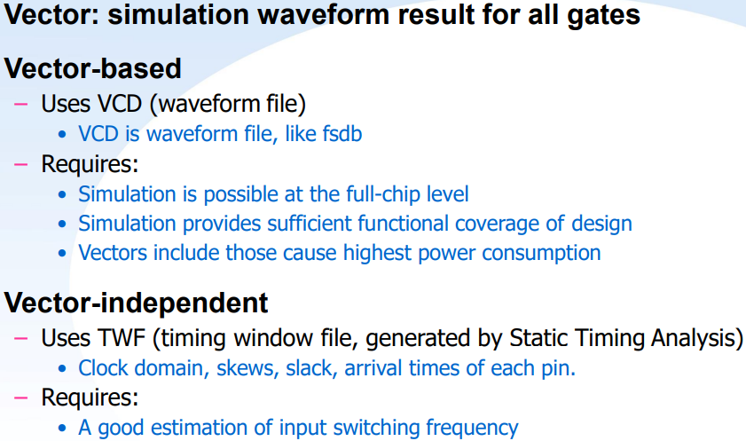

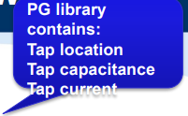
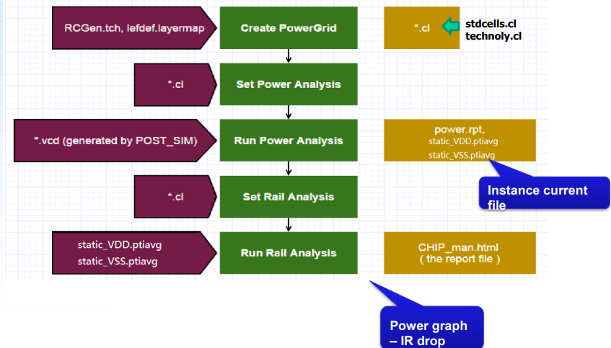

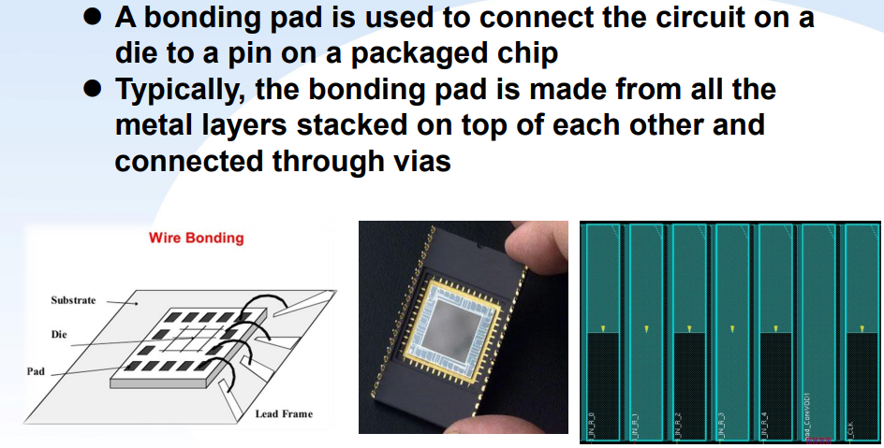

Bonding pads insertion flow:
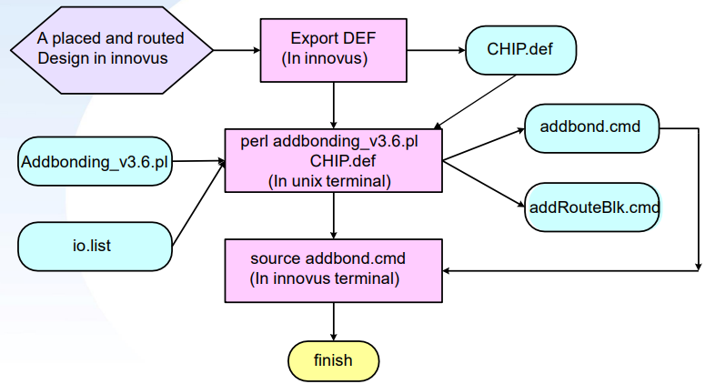

Introduction of LEF Files
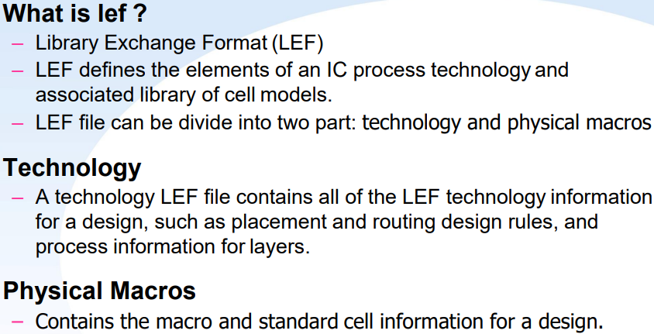
Technology LEF file: Cell library LEF file:

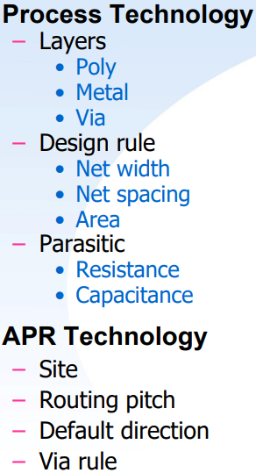
Introduction of LIB Files
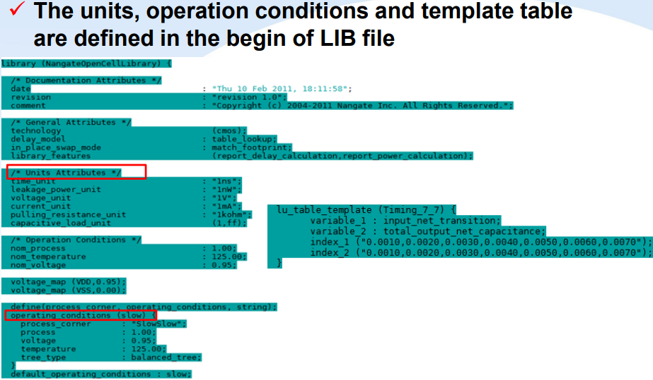
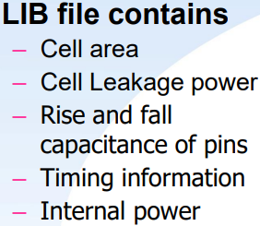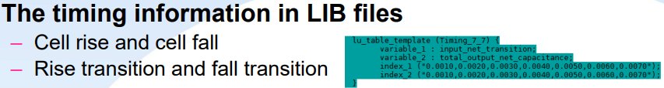
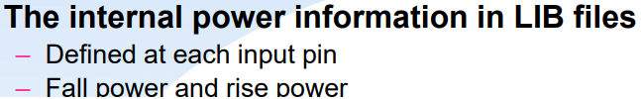

Cell-based Design Flow:
